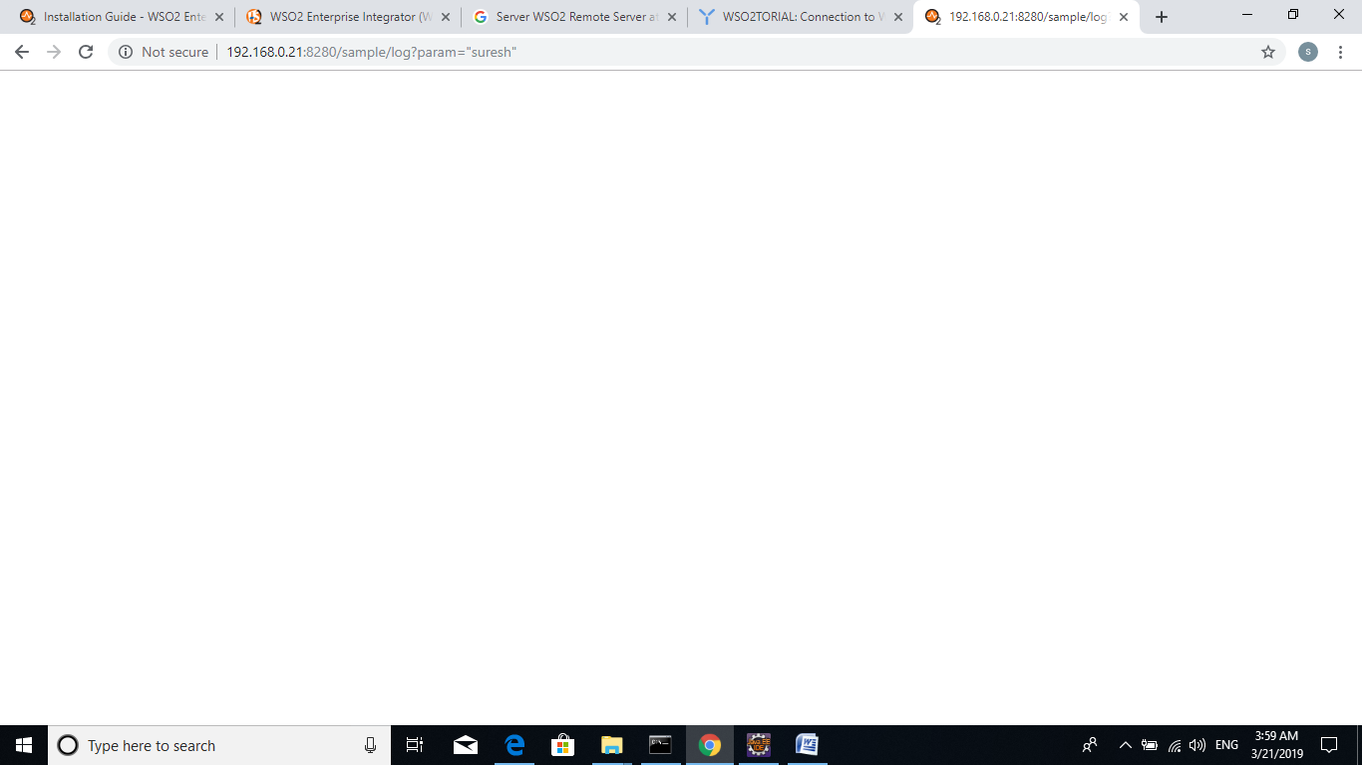

[2019-03-21 03:31:34,768] [] INFO - ApplicationManager Deploying Carbon Application : HMRCSamplesDistComposite_1.0.0.car...

[2019-03-21 03:31:38,667] [] INFO - DependencyTracker Sequence : loggingSeq was added to the Synapse configuration successfully - [ Deployed From Artifact Container: HMRCSamplesDistComposite ]

[2019-03-21 03:31:38,669] [] INFO - SequenceDeployer Sequence named 'loggingSeq' has been deployed from file : C:\Program Files\WSO2\Enterprise Integrator\6.4.0\wso2\tmp\carbonapps\-1234\1553119294769HMRCSamplesDistComposite_1.0.0.car\loggingSeq_1.0.0\loggingSeq-1.0.0.xml

[2019-03-21 03:31:38,757] [] INFO - API Initializing API: callit

[2019-03-21 03:31:38,762] [] INFO - DependencyTracker API : callit was added to the Synapse configuration successfully - [ Deployed From Artifact Container: HMRCSamplesDistComposite ]

[2019-03-21 03:31:38,764] [] INFO - APIDeployer API named 'callit' has been deployed from file : C:\Program Files\WSO2\Enterprise Integrator\6.4.0\wso2\tmp\carbonapps\-1234\1553119294769HMRCSamplesDistComposite_1.0.0.car\callit_1.0.0\callit-1.0.0.xml

[2019-03-21 03:31:38,766] [] INFO - ApplicationManager Successfully Deployed Carbon Application : HMRCSamplesDistComposite_1.0.0 {super-tenant}

[2019-03-21 03:33:16,552] [] INFO - CarbonAuthenticationUtil 'admin@carbon.super [-1234]' logged in at [2019-03-21 03:33:16,552+0530]

[2019-03-21 03:39:08,720] [] INFO - LogMediator To: /sample/log, MessageID: urn:uuid:bb282a60-1357-481b-b030-fafff3790c3c, Direction: request, testProperty = this is test Proerty

[2019-03-21 03:39:45,822] [] INFO - LogMediator To: /sample/log, MessageID: urn:uuid:412f8c73-df88-43d2-b732-255005327a6f, Direction: request, testProperty = this is test Proerty

[2019-03-21 03:47:10,757] [] INFO - ApplicationManager Undeploying Carbon Application : HMRCSamplesDistComposite_1.0.0...

[2019-03-21 03:47:11,768] [] INFO - DependencyTracker API : callit was removed from the Synapse configuration successfully - [ Deployed From Artifact Container: HMRCSamplesDistComposite ]

[2019-03-21 03:47:11,779] [] INFO - APIDeployer API named 'callit' has been undeployed

[2019-03-21 03:47:11,861] [] INFO - DependencyTracker Sequence : loggingSeq was removed from the Synapse configuration successfully - [ Deployed From Artifact Container: HMRCSamplesDistComposite ]

[2019-03-21 03:47:11,862] [] INFO - SequenceDeployer Sequence named 'loggingSeq' has been undeployed

[2019-03-21 03:47:11,900] [] INFO - ApplicationManager Successfully Undeployed Carbon Application : HMRCSamplesDistComposite_1.0.0 {super-tenant}

[2019-03-21 03:47:11,916] [] INFO - ApplicationManager Deploying Carbon Application : HMRCSamplesDistComposite_1.0.0.car...

[2019-03-21 03:47:13,195] [] INFO - DependencyTracker Sequence : loggingSeq was added to the Synapse configuration successfully - [ Deployed From Artifact Container: HMRCSamplesDistComposite ]

[2019-03-21 03:47:13,196] [] INFO - SequenceDeployer Sequence named 'loggingSeq' has been deployed from file : C:\Program Files\WSO2\Enterprise Integrator\6.4.0\wso2\tmp\carbonapps\-1234\1553120231922HMRCSamplesDistComposite_1.0.0.car\loggingSeq_1.0.0\loggingSeq-1.0.0.xml

[2019-03-21 03:47:13,222] [] INFO - API Initializing API: callit

[2019-03-21 03:47:13,233] [] INFO - DependencyTracker API : callit was added to the Synapse configuration successfully - [ Deployed From Artifact Container: HMRCSamplesDistComposite ]

[2019-03-21 03:47:13,234] [] INFO - APIDeployer API named 'callit' has been deployed from file : C:\Program Files\WSO2\Enterprise Integrator\6.4.0\wso2\tmp\carbonapps\-1234\1553120231922HMRCSamplesDistComposite_1.0.0.car\callit_1.0.0\callit-1.0.0.xml

[2019-03-21 03:47:13,235] [] INFO - ApplicationManager Successfully Deployed Carbon Application : HMRCSamplesDistComposite_1.0.0 {super-tenant}

[2019-03-21 03:47:25,475] [] INFO - LogMediator To: /sample/log, MessageID: urn:uuid:e0d4125b-249a-4da4-a735-318c10155df7, Direction: request, ============testProperty1 = this is test Proerty, ++++++++++++++++testProperty2 = null

[2019-03-21 03:47:59,003] [] INFO - LogMediator To: /sample/log?param=suresh, MessageID: urn:uuid:03c2af3b-e33e-45c1-b3da-f6b8a5a58f9c, Direction: request, ============testProperty1 = this is test Proerty, ++++++++++++++++testProperty2 = null

[2019-03-21 03:49:39,642] [] INFO - LogMediator To: /sample/log?param=%22suresh%22, MessageID: urn:uuid:16c72d36-0564-4fca-9046-1b1befa5cf19, Direction: request, ============testProperty1 = this is test Proerty, ++++++++++++++++testProperty2 = null

[2019-03-21 03:51:43,760] [] INFO - ApplicationManager Undeploying Carbon Application : HMRCSamplesDistComposite_1.0.0...

[2019-03-21 03:51:44,161] [] INFO - DependencyTracker API : callit was removed from the Synapse configuration successfully - [ Deployed From Artifact Container: HMRCSamplesDistComposite ]

[2019-03-21 03:51:44,163] [] INFO - APIDeployer API named 'callit' has been undeployed

[2019-03-21 03:51:44,168] [] INFO - DependencyTracker Sequence : loggingSeq was removed from the Synapse configuration successfully - [ Deployed From Artifact Container: HMRCSamplesDistComposite ]

[2019-03-21 03:51:44,169] [] INFO - SequenceDeployer Sequence named 'loggingSeq' has been undeployed

[2019-03-21 03:51:44,179] [] INFO - ApplicationManager Successfully Undeployed Carbon Application : HMRCSamplesDistComposite_1.0.0 {super-tenant}

[2019-03-21 03:51:44,179] [] INFO - ApplicationManager Deploying Carbon Application : HMRCSamplesDistComposite_1.0.0.car...

[2019-03-21 03:51:44,218] [] INFO - DependencyTracker Sequence : loggingSeq was added to the Synapse configuration successfully - [ Deployed From Artifact Container: HMRCSamplesDistComposite ]

[2019-03-21 03:51:44,219] [] INFO - SequenceDeployer Sequence named 'loggingSeq' has been deployed from file : C:\Program Files\WSO2\Enterprise Integrator\6.4.0\wso2\tmp\carbonapps\-1234\1553120504180HMRCSamplesDistComposite_1.0.0.car\loggingSeq_1.0.0\loggingSeq-1.0.0.xml

[2019-03-21 03:51:44,224] [] INFO - API Initializing API: callit

[2019-03-21 03:51:44,225] [] INFO - DependencyTracker API : callit was added to the Synapse configuration successfully - [ Deployed From Artifact Container: HMRCSamplesDistComposite ]

[2019-03-21 03:51:44,225] [] INFO - APIDeployer API named 'callit' has been deployed from file : C:\Program Files\WSO2\Enterprise Integrator\6.4.0\wso2\tmp\carbonapps\-1234\1553120504180HMRCSamplesDistComposite_1.0.0.car\callit_1.0.0\callit-1.0.0.xml

[2019-03-21 03:51:44,226] [] INFO - ApplicationManager Successfully Deployed Carbon Application : HMRCSamplesDistComposite_1.0.0 {super-tenant}

[2019-03-21 03:52:18,111] [] INFO - LogMediator To: /sample/log?param=%22suresh%22, MessageID: urn:uuid:166869fd-36e3-4dfe-96ac-1104a49eef76, Direction: request, ============testProperty1 = this is test Proerty, ++++++++++++++++testProperty2 = "suresh"

[2019-03-21 03:56:54,763] [] INFO - CarbonAuthenticationUtil 'admin@carbon.super [-1234]' logged in at [2019-03-21 03:56:54,763+0530]

[2019-03-21 03:57:17,606] [] INFO - CarbonAuthenticationUtil 'admin@carbon.super [-1234]' logged in at [2019-03-21 03:57:17,606+0530]

[2019-03-21 03:57:13,742] [] INFO - CarbonAuthenticationUtil 'admin@carbon.super [-1234]' logged in at [2019-03-21 03:57:13,742+0530]

